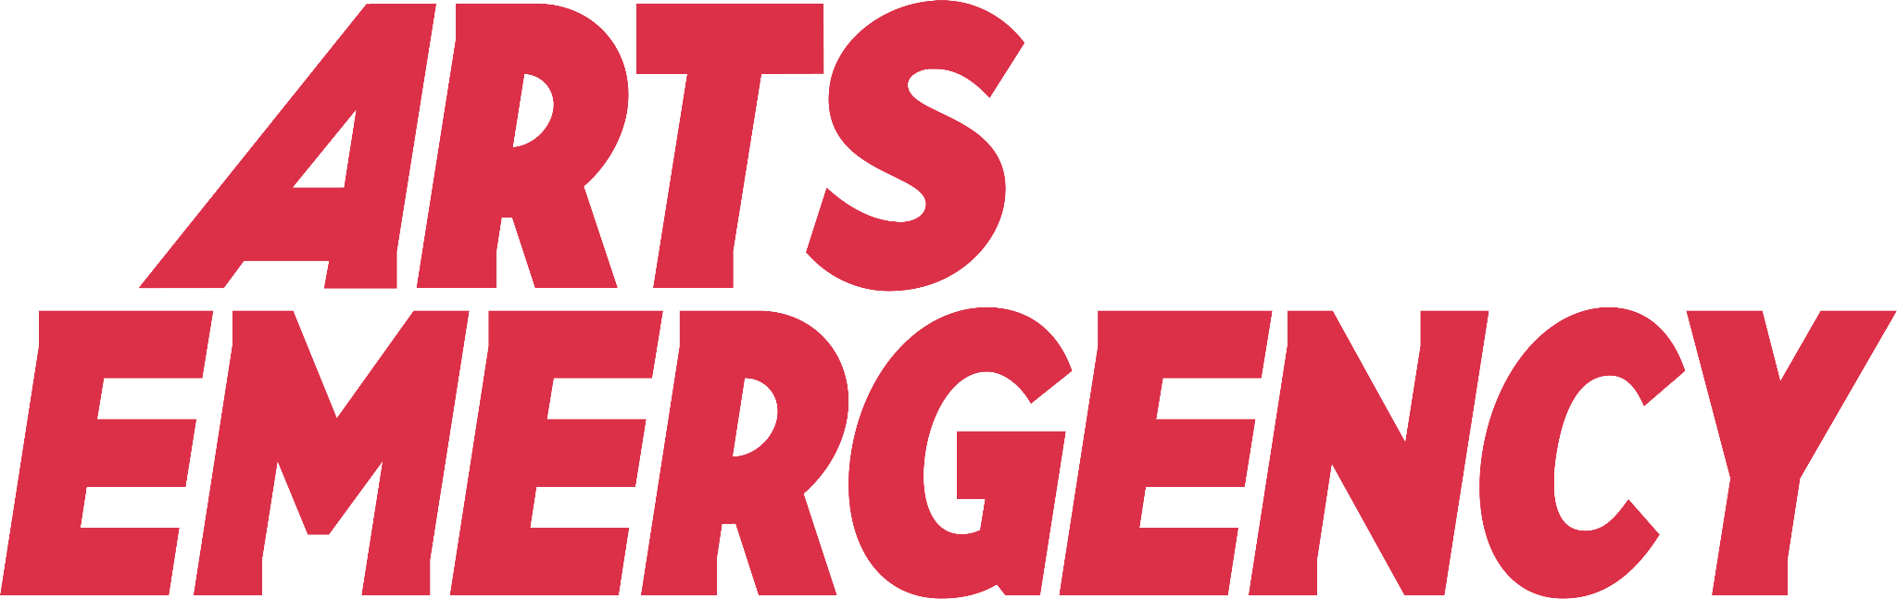Merseyside Mentoring Officer

Application Pack

June 2024

About us

**Our values**

Arts Emergency is a mentoring charity and support network. Since 2013, we have worked to address the inequalities in the creative and cultural sectors. Founded in Hackney by two friends, activist Neil Griffiths and comedian Josie Long, we now support 1,300 brilliant young people across the UK. We provide guidance so they can chart their own course. We create connections to help them get ahead.

**Optimism**

We are optimistic about the future of society, the potential for change and transformation.

**Support**

We provide long-lasting support to young people and to the network of professionals driving change. Through this we create a community.

**Persistence**

We will be a persistent source of opportunity for young people, creating trust with our partners and with young people.

**Integrity**

Our programmes will be transformative, meeting the needs of young people in an evidence-based way and empowering young people to influence our programme.

**Inclusion**

We will actively improve our inclusion of young people, assessing barriers to engagement and working with partners to provide for everyone in need.

**See some of the results of our work in our** [**2023 Impact Report**](https://online.fliphtml5.com/yawnj/gkmn/#p=1).

What we do

Arts Emergency provides 16-25 year olds in Merseyside, London, Greater Manchester and beyond with a trained mentor working in their field of interest. Mentors help Young Talent set goals, explore their passions and make decisions about higher education, training and careers.

After they complete a year of mentoring, Young Talent can continue to access opportunities, advice, resources and paid work from the Arts Emergency Network until they turn 26. The network is made up of thousands of cultural professionals who’ve all offered to share crucial gateways into hard to crack industries like TV, publishing and architecture with young people underrepresented in those fields. High profile members include comedians Nish Kumar and Sara Pascoe, actors Nikesh Patel and Julie Hesmondhalgh, and writers Neil Gaiman and Sarah Perry.

*“Arts Emergency has done more for me than I ever thought possible, it has*

*opened doors I thought were closed. It has given me hope.”*

- DEJI, YOUNG TALENT

**Find out what our mentees have to say:**

[**Arts Emergency Mentoring Celebration Event 2023**](https://www.youtube.com/watch?v=cgsRAcZ_RrI)

Our plans for the future

Our vision is of a society where every young person gets a fair chance to

flourish and every opportunity to contribute to the culture in which they live.

This is an exciting time to join Arts Emergency and help to shape the future

of the organisation. In 2022, we conducted a strategic review to inform our

direction and update our mission and impact. We recruited a new Chair and

new board members to help us achieve this and welcomed a new Youth

Collective, who ensure that young people’s voices are amplified through our

work. Additionally, two Youth Collective members serve on the board as

Young Trustees.

This is a critical time as we expand nationally to meet the urgent need for our support. Having grown five-fold since 2016, we have ambitious plans to

grow our flagship mentoring programme, including increasing capacity in

the regions where we already deliver, expanding to new regions across the

country, and exploring the potential for new ways of working to reach more

young people in need of support.

We are also laying the groundwork for enhancing how we provide long-term

support for our young people's personal and professional development through our Community offer. We know that breaking into the industry doesn't happen overnight, and we are committed to facilitating young

people on their journey until their 26th birthday, with the support of our Network members.

Our team

The Arts Emergency team is a group of passionate and dedicated staff

and trustees who bring together a wealth of experience from the charity

and cultural sectors.

[**Meet our team**](https://www.arts-emergency.org/about-us/our-people)

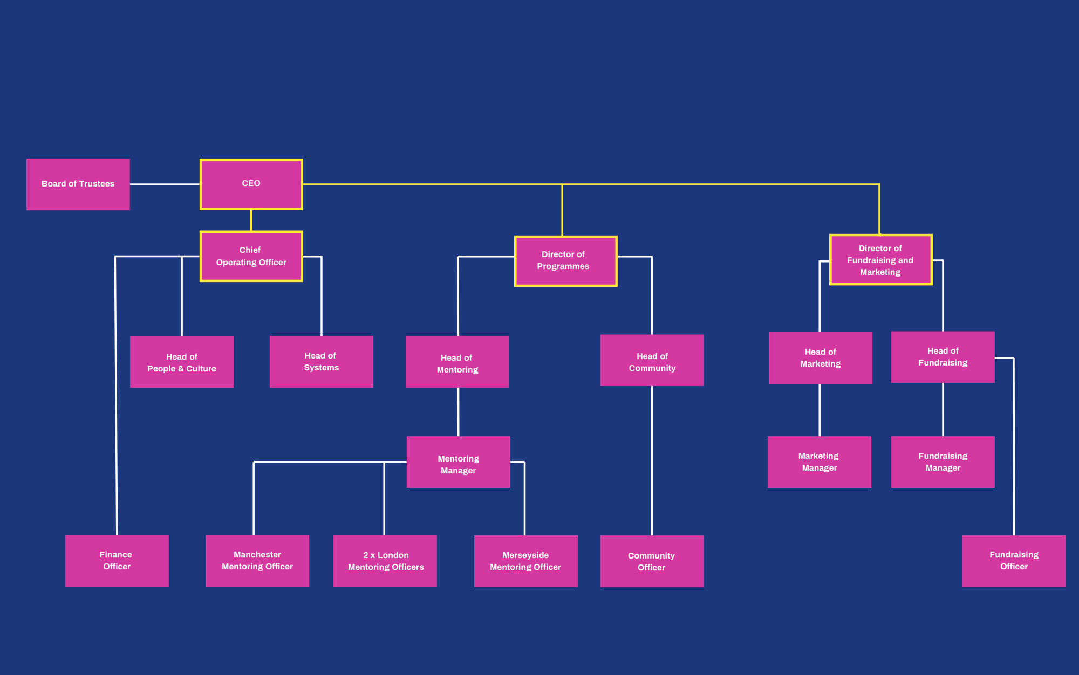

Commitment to equality and diversity

Arts Emergency is committed to being a welcoming and inclusive organisation. We’re dedicated to social justice and making the arts and humanities equitable for all. We help our volunteers to address the structural inequalities in the cultural and creative industries, and use our voice to influence gatekeepers to make real, long-term changes.

When we recruit we will always: show the salary, pay a living wage, and won’t demand a degree as an essential criteria (unless a specific qualification is required for a role). We particularly welcome applications from disabled people, LGBTQIA+ people, Black, Asian and minority ethnic candidates.

*“Our future cultural landscape is in danger of being populated exclusively by the children of the wealthy and well-connected. I love Arts Emergency because it works to bridge this gap. To create the opportunities that have been taken away.”*

- JULIE HESMONDHALGH, ACTOR

We are committed to the employment and development of disabled people. We guarantee to interview anyone who identifies as disabled and whose application meets the person specification for a post. To be invited to interview, you must show in your application that you meet the person specification for the role. If you tell us that you have access requirements or any requests to make you comfortable, we can make reasonable adjustments to the interview process, and, if you join us, to your work arrangements.

Merseyside Mentoring Officer

* **Permanent, 3.5 days a week**
* **£30,500 per annum pro rata, plus 6% pension contribution.**
* **This role can be home or office-based. Arts Emergency operates a 35-hour week, we will consider compressed or annualised hours.**

Arts Emergency have been supporting young people through our mentoring programme since 2011. During this time, we’ve seen a huge community of mentors from across the UK’s creative industries come together to support nearly 2,000 underrepresented young people to pursue higher education, creativity and careers.

As the Merseyside Mentoring Officer, you will work to recruit, match and support mentoring pairs across Merseyside. This is a busy, fun, and super rewarding role where you’ll get to work independently while being supported by the Mentoring Manager, your Mentoring team colleagues, and the wider Arts Emergency team around the country.

Key tasks

• Recruit and maintain a network of volunteer mentors, in collaboration with the wider Mentoring and Arts Emergency team

• Organise mentor training events and carry out necessary safeguarding measures, including enhanced checks with the Disclosure and Barring Service (DBS) for volunteers

• Promote the mentoring programme with schools, colleges, and other referral partners

• Manage existing relationships and develop new ones with schools, colleges, and other referral partners

• Manage application and onboarding processes effectively

• Ensure the best possible mentor matches for young people and provide high-quality support throughout their mentoring relationship

• Develop value-added opportunities for mentees to gain first-hand knowledge and experience in their fields of interest, and to achieve their personal goals

• Monitor the programme and share updates proactively with the Mentoring Manager, including reviewing and responding to mentor reports

• Contribute to planning on-boarding or celebration events for mentoring pairs

• Represent Arts Emergency at events, developing relationships with supporters and cultural organisations, and acting as an ambassador for the organisation’s work

• Ensure compliance with all relevant policies and procedures, flagging causes for concern with the Designated Safeguarding Officer (DSO) if needed

• Work with the wider team to curate monthly newsletters, sharing opportunities with London-based mentees

• Undertake any task that may be requested from time to time that may be consistent with the nature and scope of this post

• Maintain the ethos and values of the organisation and positively promote the work and its activities at all times

Key results/objectives

• There are sufficient volunteer numbers for the project to commence

• Partners understand the benefits of the programme and sign a partner agreement

• Partner recruitment is carried out, and there are sufficient applications received for the project to commence

• All eligible applicants have been met individually (either digitally or in person) to assess needs and address expectations

• Sufficient mentors have been trained, and enhanced DBS certificates and safeguarding measures are in place for those matched, in accordance with our safeguarding policy

• Accurate records are kept on Salesforce, with reports regularly received from volunteers

• Value-added opportunities are offered regularly to individuals and through the mentee newsletter

• Communication with the wider Arts Emergency team is clear and proactive, issues are addressed quickly, and progress is reported on regularly

• Feedback from both mentors and mentees are largely positive, and show significant impact, with a majority of mentees finishing mentoring and feeling positive about their futures

Person specification

We are aware that everyone has a range of skills and experiences and that transferable skills or similar experiences may not align exactly with the person specification outlined here. If you feel that you could successfully fulfil the responsibilities of the role, we would encourage you to apply, even if you don’t meet every criteria in the person specification. Training and support can be provided for the successful candidate to support their development in areas of the role with which they are less familiar.

**Qualifications**

No specific qualifications are required for this role

**Experience**

• Experience working with young people aged 16-18

• Experience of project management within a service delivery context

• Experience of managing relationships with partner organisations and/or skilled volunteers

• Experience of programme delivery in a related field (e.g. youth work, arts and culture, education)

**Skills & Abilities**

• Excellent interpersonal and relationship-building skills with diverse stakeholders

• Good presentation skills and confident at public speaking

• Good administrative and organisational skills

• Time management skills - the ability to work to deadlines, and under pressure, balancing several priorities at once

• Creative thinking - ability to recognise and capitalise on value-added opportunities for mentors and mentees

• Excellent attention to detail and accuracy in recording important information

• Capability in using standard office programmes, web- based apps, and databases

**Knowledge**

• Knowledge of the context and issues affecting young people in Merseyside aged 16-18

• Knowledge of the creative and cultural industries in Merseyside

• Knowledge of the education system and/or careers guidance

**Personal qualities**

• Commitment to upholding Arts Emergency’s values of being bold, optimistic, and community-led

• A demonstrable passion for social justice

• A ‘can-do’ attitude

• Passionate and driven to make a positive impact on the world

• Always learning: a self-starter, motivated, eager to learn

• A people person, inspirational and brilliant at working closely with multiple stakeholders

• Team-oriented but takes individual responsibility

• Resourceful and embraces challenge and change

• Self-discipline to work independently and communicate proactively with the wider team

• Willingness to work flexibly to meet the demands of the role

**Working conditions**

The role can be home or office based, or hybrid. The role can be home or office based, or hybrid. Arts Emergency’s head office is in Manor House at Unit W3, 8 Woodberry Down, London N4 2TG and our Manchester office is at Peter House, Oxford Street. We also have access to Spaces offices around the country which can be used by all staff if an office space is needed outside these areas - including a co-working space off Wood Street in Liverpool city centre.

Regular travel across Merseyside is essential as part of programme delivery. Where off-site working is required as part of programme delivery, travel expenses will be covered within Merseyside. We will occasionally ask you to travel to other offices or locations for training and away days. Travel expenses for these events will be covered, and we will offer remote options when necessary, and ensure accessibility requirements are taken into account.

Arts Emergency operates a 35-hour week, and we will consider compressed or annualised hours. There may be occasional evening and weekend work. We operate a time-off-in-lieu system.

How to apply

We will be hosting an optional Zoom on Wednesday 24th July at 6pm for prospective applicants to learn more about the role, the Mentoring team, and Arts Emergency before they apply. Register via the link on our jobs webpage.

To apply please complete the following three steps:

1. Download and fill in the application forms from our jobs webpage.

There are two parts to the application:

* **Part One** asks for your personal information, education, work history, referees
* **Part Two** asks for supporting statements in relation to the job application.

You can return the application forms as a Word Document or PDF. If you prefer you can talk through the Part Two questions in audio files.

To transfer audio files, we suggest uploading to [wetransfer.com](http://wetransfer.com) and use the ‘get transfer link’ option, then share the generated link in your email.

2. Complete our Equality and Diversity Monitoring Survey* (link available on the jobs webpage)

3. Once completed, please send the application documents (Parts One and Two) to [jobs@arts-emergency.org](mailto:jobs@arts-emergency.org) by 10am on Monday 29 July 2024 with AE-MMO in the subject line.

Interviews will be held in Liverpool the week commencing 5th August 2024.

Please see our [**privacy policy**](https://www.arts-emergency.org/privacy-policy) to find out more about how we handle your data. You’ll also find further information within the application form.

*The survey is anonymous and not linked in any way to your application. Any information you provide will be used by Arts Emergency to monitor the demographics of candidates applying for roles and make improvements in line with our diversity and inclusion ambitions. This data will be treated in accordance with the General Data Protection Regulation 2018.

Contact us

If you have any questions about the role, please contact Joe Burton, Head of Mentoring, at [**joe@arts-emergency.org**](mailto:joe@arts-emergency.org).

If you have any questions about the application process, please contact [**jobs@arts-emergency.org**](mailto:jobs@arts-emergency.org).

Arts Emergency

Unit W3

8 Woodberry Down

London

N4 2TG

[www.arts-emergency.org](http://www.arts-emergency.org)

Registered Charity Number 1152377